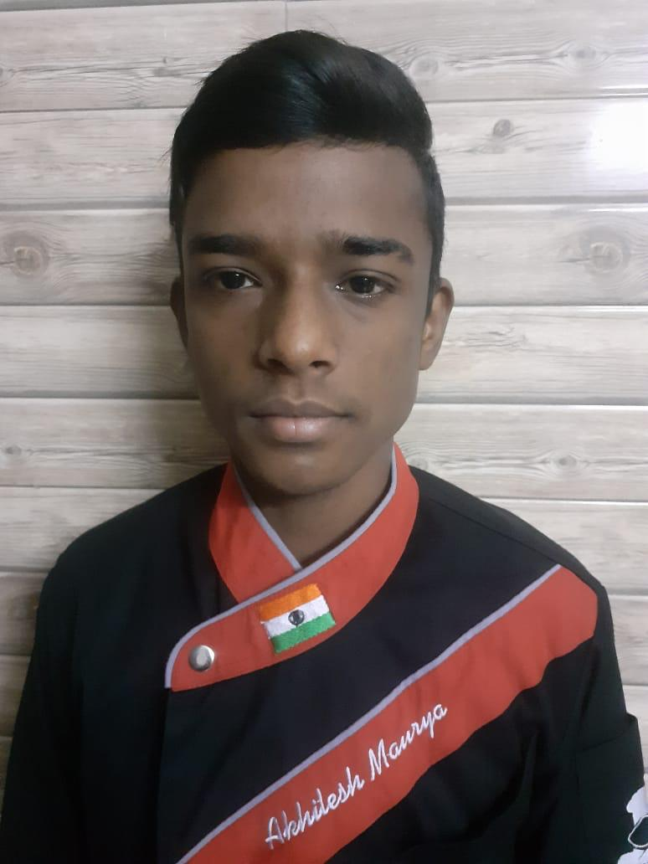

**Name:Akhilesh Maurya**

**E-mail:mauryaakhilesh9781@gmail.com**

**Phone: +919781104094**

**AREA OF SPECIALISATION – kitchen operation**

**CAREER OBJECTIVE**

**I want to work in an organization in which I can give my best to cop up with new challenges & I want to see myself as a person rising in the field throughout hard work and utilization of my education practically**

**EDUCATIONAL QUALIFICATIONS**

|  |  |  |  |
| --- | --- | --- | --- |
| Course (Stream)/Examination | Institution/University | Month/ Year of Passing | Performance |
| B.Sc. Culinary Arts | Chitkara School of Culinary Arts | 2019-2022 | Presently in the first semester |
| 10TH | IS dev samaj senior secondary school (CBSE ) | 2016 | 5.8 CGPA |
| 12TH (Arts) | Gyandeep Model school ( CBSE ) | 2019 | 58.5 % |
| 1st Semester | Chitkara School of Culinary Arts | 2019 | _____ CGPA |

**KEY SKILLS**

* Good communication skill.
* Know the value of teamwork.
* Creative while preparing food.
* Never limit my imagination while working.
* Time management
* Self - motivated

**INTERESTS & ACHIEVEMENTS**

* Attended 7 day’s workshop of Global week
* Attended 1 day's workshop of Chitkara school of culinary start
* I love to travel & explore
* My cutting skills are very good
* My dream is I want to become a Michellin star chef

**PERSONAL VITAE**

Date of Birth: 18/12/1999

Address: #2561 vikas nagar mauli jagran

Chandigarh ( U.T )

Languages: English , Hindi, Punjabi

Place of Issue: CHANDIGARH

*(Signatures*)